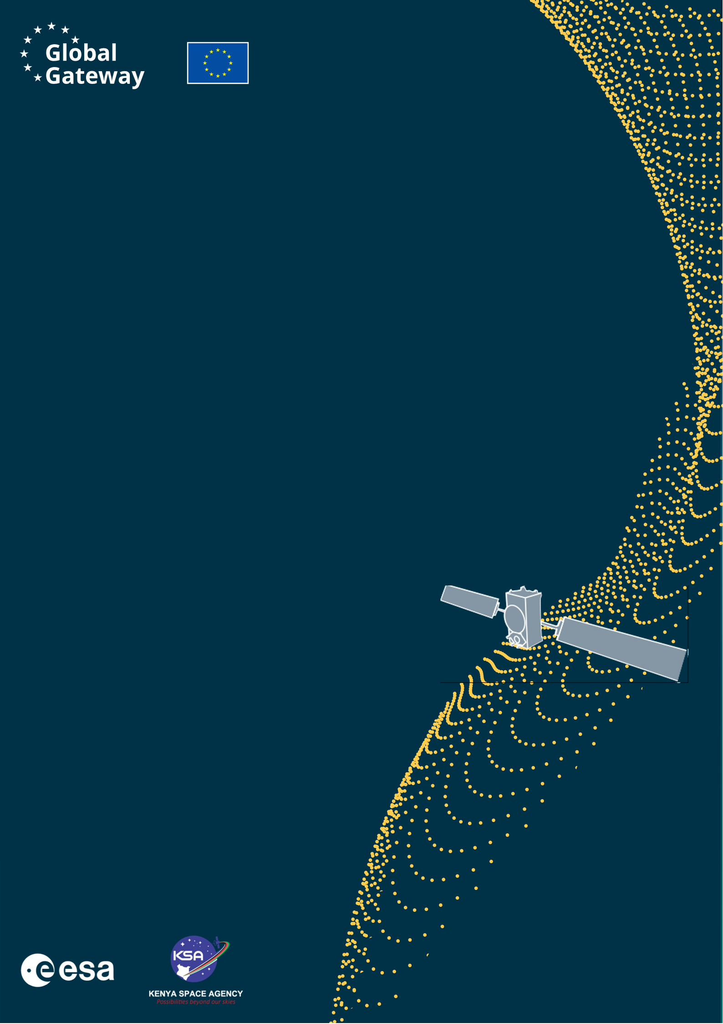
Africa–EU Space Partnership Programme
Africa Business Innovation Lab (ABIL)

ABIL EXPLORE
Application

The Africa Business Innovation Lab (ABIL) is an initiative under the Africa–EU Space Partnership Programme (AESPP) funded by the European Union (represented by European Commission’s DG-INTPA) within the Global Gateway initiative and delegated to European Space Agency (ESA) for the implementation in close collaboration with the Kenya Space Agency (KSA).

Table of contents
1. Executive Summary 8
2. Technical Proposal and Exploitation Pathway / Initial Business Case 9
2.1 Background and Experience (1 page) 9
2.2 Market Opportunity (3 pages) 9
2.3 Technology and Relevance to ABIL EXPLORE / EO Innovation (3 pages) 10
3. Activity Proposal 12
3.1 Milestone Planning 12
3.2 Work Breakdown 12
3.3 Cost Planning 12
3.4 Key Resources and Facilities 13
4. Management Proposal 14
General Management (1 page): 14
5. Annexes 15

[Project Name]

ABIL EXPLORE Application

EXPLORE Open Call
Minimal Viable Product/Service
Exploitation Pathway / Initial Business Case

Kenya

Kenya

[Company Logo(s)]

Project Name | :
Project Reference Number | :
Company Name(s) | :
Project Manager(s) | :
Date of Submission | :

**Please delete the guidance notes (blue text) associated with
each section prior to submitting**

[Sender: Name]
[Entity Name]
[Address]
[E-Mail]
[Web Site]
EXPLORE Open Call - Kenya
African Business Innovation Lab (ABIL)
Represented by
STAM s.r.l.,
Piazza della Vittoria 14/25 – 16121
Genoa, Italy

For the attention of
ABIL EXPLORE Open Call Manager

SUBJECT: Application for ABIL EXPLORE Kenya
REF: [please insert your own reference number here]

Dear Madam, dear Sir,
In response to the ABIL EXPLORE Kenya Open Call for Proposals issued by STAM s.r.l. (hereinafter referred to as STAM), as manager of the African Business Innovation Lab (ABIL), [Company Name] is pleased to submit our proposal for the project named [insert project name].

Please find included the following information:
- Requirements Checklist
- Executive Summary
- Technical Proposal and Exploitation Pathway / Initial Business Case
- Activity Proposal
- Management Proposal
- Annexes

1. We hereby declare that the Application is compliant with the Requirements set out in the Call for Proposals as shown in the Requirement Checklist below.
2. We hereby confirm that the contract conditions have been read, understood and accepted, and any of the Applicant’s terms and conditions do not apply.

Any queries relevant to the proposal are to be addressed to the attention of:
[Name(s)]
[Address(es)]
[Phone]
[E-Mail]

Contact information of the person(s) who will be in charge of the day-to-day management:
[Name(s)]
[Address(es)]
[Phone]
[E-Mail]

Contact information of the legal representative who will be signing the contract:
[Name(s)]
[Address(es)]
[Phone]
[E-Mail]

Signature(s): Date: [insert date of submission]

ABIL EXPLORE General Application Requirements  (for EXPLORE Open Call Projects): | Compliance statement
The Applicant is a legal entity registered under the laws of Kenya. | [compliant/non-compliant/partially-compliant]
The Applicant is a Kenyan start-up, SME, University or Research Organisation developing or validating an innovative Earth Observation-related technology, application, service, method | [compliant/non-compliant/partially-compliant]
The Applicant is headquartered in Kenya | [compliant/non-compliant/partially-compliant]
The Applicant is fully compliant with Kenyan tax and social security obligations | [compliant/non-compliant/partially-compliant]
The Applicant does not conduct business activities promoting, or being related to alcohol abuse, tobacco, religion, politics, intolerance, violence, firearms, pornography, obscenity, gambling or illegal drugs. | [compliant/non-compliant/partially-compliant]
The Applicant is able to communicate in English. | [compliant/non-compliant/partially-compliant]
The Applicant states that the terms and conditions of the Draft ESA EXPLORE Funding Contract are accepted without any reservations. | [compliant/non-compliant/partially-compliant]
The Funding is linked to work packages within the ABIL EXPLORE project only | [compliant/non-compliant/partially-compliant]
The Applicant declares that the activities proposed under the submitted ABIL EXPLORE project are not and have not been funded through other means (e.g. National public funding, International public funding etc.) | [compliant/non-compliant/partially-compliant]
The Funding is granted in net amounts (not including VAT). | [compliant/non-compliant/partially-compliant]
The information provided in the application and in the supplementary data sheet is binding and forms the basis of the funding granted. Any changes in this information must be reported immediately and are subject to approval. | [compliant/non-compliant/partially-compliant]

I hereby declare that my application is compliant to the EXPLORE Open Call General Application Requirements.

Signature(s): Date: [insert date of submission]

Data Protection

By submitting the application for ABIL EXPLORE Kenya, the Applicant gives by signing beneath this statement, free, specific, informed and unambiguous consent to STAM s.r.l. (Data Controller) with the controlling of the personal data contained in the proposal and business application in relation to this Open Call and for the purpose of possible selection for ESA EXPLORE Funding Kenya upon fulfilment of all requirements set in the Open Call. Such consent to the controlling of the personal data shall be permitted only for a necessary period up to a maximum duration of 1 (one) year upon signature of the present consent.

The Applicant shall have the right to information and the right of access to its personal data, right to rectification and erasure (right to be forgotten), right to restriction of processing, right to data portability, right to object, right not to be subject to a decision based solely on automated processing. The particularities of these rights are stipulated in the Regulation (EU) 2016/679 of the European Parliament and the Council.

The data subject shall have the right to withdraw its consent at any time. Such withdrawal of consent shall not affect the lawfulness of processing based on consent before its withdrawal. It shall be as easy to withdraw as to give consent. STAM as data Controller can be contacted via the e-mail address: privacy@stamtech.com.

The data subject has moreover the right to lodge a complaint with a supervisory authority established in each of the EU Member State as indicated in the GDPR legal framework.

I hereby give full consent to the above statement.

Name(s) and Signature(s): Date:

Executive Summary
The Executive Summary shall provide the following information in maximum 1 page:

Entities involved:
Who is the applicant and who are the key partners, if any, including other technology providers, data providers, research organisations, pilot users, customers or other stakeholders involved in the activity.

EO innovative technology / asset / data / solution to be developed or transferred:
Please select the main nature of the proposed ABIL EXPLORE activity. More than one box may be checked where justified:
☐ Upstream segment (space segment e.g. satellite, a sub-system of a satellite etc))
☐ Downstream segment (any kind of EO application, e.g. AI for EO)
☐ Other research areas with the potential to disrupt Earth Observation applications and technology
Provide a brief description of the innovative EO technology, data, asset, method, know-how or solution that is being developed, transferred, adapted or exploited, including its relevance to ABIL EXPLORE and to Kenyan/African needs.

Target application, stakeholders and exploitation pathway / initial business case:
The targeted Kenyan/African application domain and the essentials of the exploitation pathway / initial business case, including customers/users or beneficiaries, need/problem to be addressed, brief description of the proposed product/service/technology, expected feasibility evidence and next development or market-oriented steps.

Technical Proposal and Exploitation Pathway / Initial Business Case
All sub-sections included within the Technical Proposal and Exploitation Pathway / Initial Business Case chapters should be completed in a maximum total of 7 pages.

2.1 Background and Experience (1 page)

2.1.1 Team composition:
Please describe the overall team composition, including participants from all subcontractors, if any, including all key personnel (i.e. having a major role within the team and/or being responsible for one or more tasks) and their position within his/her own entity’s structure. Full CVs must be attached as annexes to the technical proposal and they do not contribute to the page limit.

2.1.2 Background of the entities involved:
Please briefly describe the relevant Earth Observation, space, non-space, technical, business and implementation capabilities and experience of the Applicant and consortium partners for the performance of the proposed work. Please provide the rationale for the involvement of the proposed consortium partners in the activity.

2.1.3 Vision:
Please describe how this activity fits into the vision of the Applicant and proposal partners including alignment with medium- or long-term objectives, synergies with other activities, relevance to the Kenyan and African EO ecosystem, and possible continuation after ABIL EXPLORE. A brief overview of the activity in the broader implementation plan of the satellite/component/product/service that the proposed innovation will enable is appreciated (including a summary of key steps for a fully-fledged offer and roll-out the product/service to the targeted application market, as well as follow-up actions to this activity (e.g. apply for further ESA or non-ESA funding, creation of a new company, licencing, commercial efforts, etc.).

2.2 Market Opportunity (3 pages)

2.2.1 Target application domain and Kenyan/African relevance:
Describe the target application domain for the proposed EO-related technology, application, service, method or capability. Explain the relevance to Kenyan and, where applicable, African needs, users, public authorities, industry, communities or environmental challenges.

2.2.2 Customers & Users:
Identify and present the targeted customers, users, beneficiaries and other relevant stakeholders of your product/service/solution, and describe their role in the value chain or ecosystem. Customers shall be understood as stakeholders who may procure, fund, deploy or sponsor your solution directly. Users shall be understood as end-users or operational users that may benefit from or interact with the solution. Customers and users may be the same, e.g. when your product/solution/service can be used as a standalone.

2.2.3 Current situation and user/customer needs:
Please present how the customers/users/stakeholders currently handle the issues that the proposed product/service/technology would address. Include a description of the problems faced in the current use case scenario, the opportunities for improvement, and the role that EO data or EO-related technology could play. Explain the impacts of those problems, e.g. large costs, safety issues, lack of performance, limited access to data, weak decision-support, maintenance issues, environmental footprint, resilience or socio-economic impacts.

2.2.4 Problem/need validation:
Provide evidence of validation of the problem(s) or need(s) by customers/users and possibly other relevant stakeholder(s). Letters of support from any relevant stakeholder stating the need for the proposed product/service will be positively evaluated and might be included in the Annex to this application, where available.

2.2.5 Value proposition of the proposed solution:
Provide a description of the proposed product, service, technology, method or capability that shall be developed, validated or demonstrated to address the identified problem of the customers/users. Describe the main benefits and present the unique and compelling value proposition. Values may be quantitative (e.g. price, accuracy, frequency, timeliness, speed of service, coverage, reduced cost) or qualitative (e.g. usability, decision-support, local relevance, trust, customer experience). This should include an initial analysis against existing products/services or current practices with which the proposed solution will compete or integrate.

2.3 Technology and Relevance to ABIL EXPLORE / EO Innovation (3 pages)

2.3.1 Involvement of technology:
Please indicate the EO technology, data, asset, know-how or technology transfer element involved in the activity. Select the relevant category or categories and then provide the requested technical description below:
☐ Upstream segment (space segment e.g. satellite, a sub-system of a satellite etc))
☐ Downstream segment (any kind of EO application, e.g. AI for EO)
☐ Other research areas with the potential to disrupt Earth Observation applications and technology
Please present the technology, EO data, asset, software, algorithm, hardware, infrastructure or know-how which is subject to development, integration, transfer, adaptation or exploitation. Characterize the space, non-space or EO heritage of the solution, clearly identifying any original development, previous use, mission/research/commercial background, and the way it will be used to support EO innovation in Kenya.

2.3.2 Innovation introduced
Please provide an overview of the innovative aspects of your technologies able to revolutionise and accelerate the future of EO.

2.3.3 Maturity of technologies required for proof-of-concept / breadboard design:
Please present the current maturity/development status of the EO-related technology, data-processing approach, asset, software, hardware, know-how or solution to be used or integrated in the proposed proof-of-concept, minimum viable product, algorithmic validation, data exploitation validation or early demonstration. Include any research paper or existing state of the art reference which represent your starting point. Provide a table including the current Technology Readiness Level (TRL) ), or other relevant maturity indication and an estimation of the final TRL expected at the end of the ABIL EXPLORE activity. Include the outcomes of any feasibility studies, proof of concept, or other similar activities. Please detail the developments to be carried out during the project that enable the expected TRL improvement.

2.3.4 Access to technology/asset/know-how:
Please provide information on the means of access to the technology, EO data, asset, software, infrastructure, model, know-how or other inputs relevant for the activity. Intellectual Property Rights (IPR), data rights, software licences, open-source/open-data licences, ownership, rights of use by third parties, trade secrets and any access limitations shall be highlighted. In cases where applicants involve additional technology providers, they should include a letter from such Technology Providers, Data Providers, or Asset Providers confirming that the applicant will have access to the relevant rights and resources for the duration of the project. A description of any existing or future limitation of access shall also be presented.

2.3.5 Potential feasibility of the application/system concept:

User and system requirements
Please present the expected requirements of the underlying product/service/technology/system, including user requirements (e.g. testing ) and technical requirements (e.g. data availability and quality, model performance, computer integration or operational constraints)

System Architecture
Please present and describe the proposed high level system architecture of the underlying product/service/technology/system and why it is considered technically feasible within the proposed ABIL EXPLORE activity duration. Present a plan/strategy for the necessary validation tasks, milestones and criteria to assess feasibility and maturity increase by the end of the activity.

Risk register
Please include a risk register describing the potential technical and business risks, their impact and likelihood and a proposed mitigation strategy.

Activity Proposal
All sub-sections included within the Activity Proposal chapter should be completed in a maximum total of 7 pages.

3.1 Milestone Planning
Please, present in chart form (GANNT or similar) the initial planning of the activity, including the overall duration, the planning and duration of each tasks, and the major milestones (e.g. kick-off, progress updates with ABIL Office, Mid-Term and Final Review). Note: the indicative duration of an ABIL EXPLORE activity shall be up to 9 months, unless otherwise approved in the specific call documentation.

3.2 Work Breakdown
Please provide an overview of the Tasks planned within the activity, the expected outputs, and illustrate how the tasks justify the ABIL EXPLORE. Duplicate the table below for each individual Task.
Task # |  |  | Start date: |  | DD/MM/YY
Task Title |  |  | End date: |  | DD/MM/YY
Task Manager
Objective(s)
Inputs
Sub-tasks
Output & Deliverables
Cost | Total Amount | ESA EXPLORE Funding |  | Other Sources

3.3 Cost Planning
Using the table below, present the total costs for the execution of the activity, and the contribution requested from the ABIL EXPLORE initiative. The maximum ABIL EXPLORE contribution is EUR 50,000 per funded activity. The final awarded amount may be lower depending on the proposed scope, maturity, budget justification, available budget and ESA/KSA approval. If co-funding, in-kind support, partner contributions, data, compute, facilities or other leveraged resources are available, they should be indicated under Other Sources.

Overall Cost
Task | Total Amount | ESA EXPORE Funding | Other Sources
Task 1 + Title
Task 2 + Title
Task ….
Total

3.4 Key Resources and Facilities
Briefly list and describe the key resources and facilities needed to conduct the activity including EO data, computing/cloud resources, software tools, laboratory or test facilities, prototyping resources, field validation resources, user/stakeholder access and any partner or supplier resources. Indicate which resources are available through the Applicant, partners, service providers or suppliers.

Management Proposal
The Management Proposal should be maximum 1 page.

General Management (1 page):
Please present how the management (including the coordination with partners), reporting, meetings and deliverables will be organized during the activity. Provide information on the activities of the Project Manager, the reporting lines within the team and the means for settling disagreements.

Annexes
- Initial Exploitation Pathway / Business Model Canvas
- Curriculum Vitae of the members of the Project team
- Letter(s) of support from customers, users, technology/data providers or other relevant stakeholders if any
- Any other relevant information about the activity or the Applicant, eligibility as Kenyan start-up/SME, access to data/technology/IP, or the proposed EO innovation, as necessary

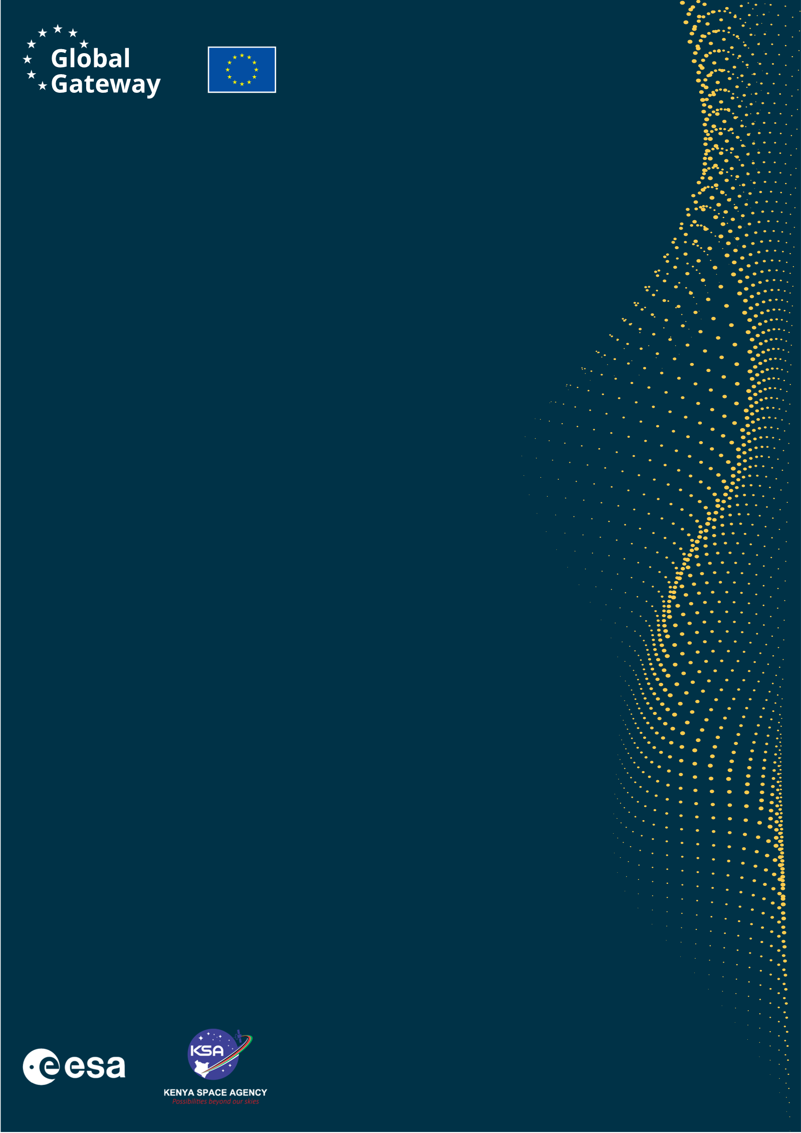

Africa–EU Space Partnership Programme
Africa Business Innovation Lab (ABIL)

WEB https://abil.ksa.go.ke/
TAGS #GlobalGatway #AESPP #ABIL

Please have the form signed by all natural persons whose personal data is provided as part of the application.
https://cdn.sci.esa.int/documents/34923/35555/1567215992116-Technology_Readiness_Levels.png/74414ed8-f42c-efe5-980d-9048ae453ca8?version=1.0&t=1567215995841

